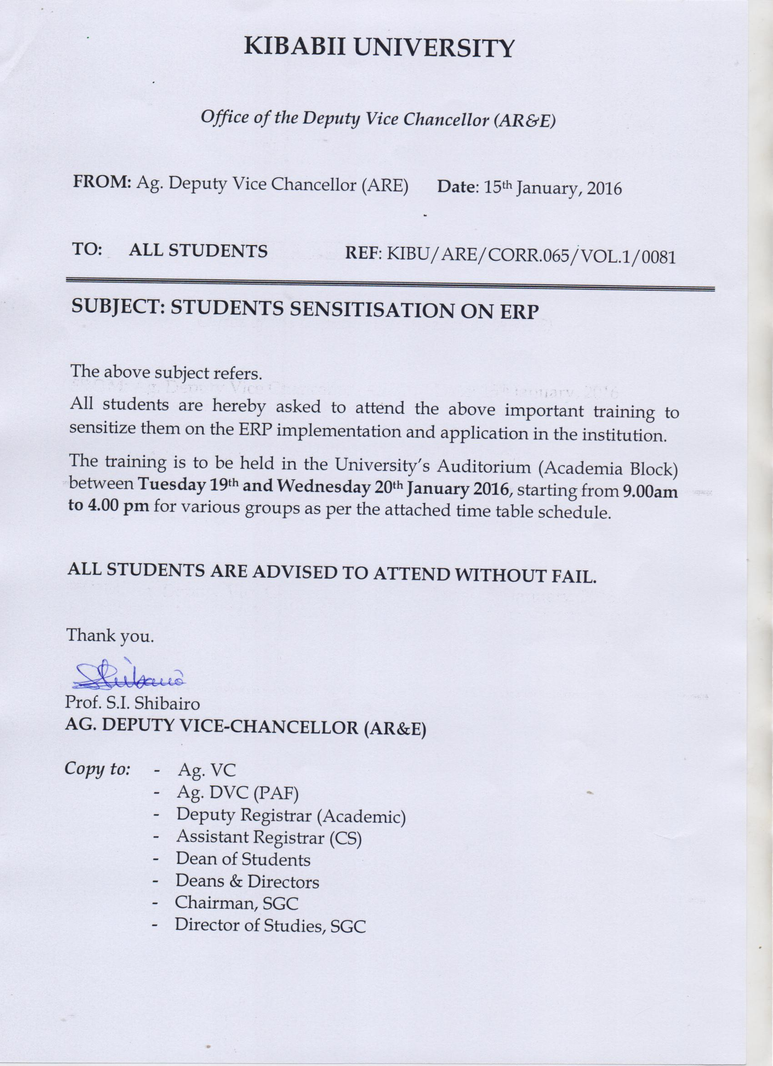

SENSITISATION SCHEDULE

VENUE: AUDITORIUM – ACADEMIA BLOCK

DATE | TIME | FACULTY/  SCHOOL | FACILITATOR
Tuesday  19th Jan., 2016 | 9:00am – 11.00am | FESS (EDA) | Constance Nganga,  Jacqueline Kimanthi  &  ICT Team
 | 2.00pm – 4.00pm | FS | Constance Nganga,  Jacqueline Kimanthi  &  ICT Team
Wednesday  20th Jan., 2016 | 9.00am – 11.00am | SOBE | Constance Nganga,  Jacqueline Kimanthi  &  ICT Team
 | 2.00pm – 4.00pm | SCAI | Constance Nganga,  Jacqueline Kimanthi  &  ICT Team

