KIBABII UNIVERSITY

RE-OPENING DATES

Kibabii University wishes to inform All Students (Bachelors, Diploma, and Certificate) of the Main Campus of the following re-opening dates.

S/NO. | STUDENTS’ GROUP | OPENING DATE
1 | 1st Years, All Diploma & Certificate Students | Monday, 7th November 2016
2 | 2nd Year Students | Tuesday, 8th November 2016
3 | 3rd Year Students | Wednesday, 9th November 2016
4 | 4th Year Students | Thursday, 10th November 2016
CONDITIONS FOR RE-OPENING
- All Students MUST pay a fine of Kshs. 1,300.00 (One Thousand Three Hundred Shillings Only) for damages in the Family Bank Account 077000029979, Bungoma Branch.
- All Students MUST clear all outstanding fees.
- Lectures will start IMMEDIATELY.

All Students MUST pay Fees in any of the following Bank Accounts:
S/No. | Bank | Branch | Account No.
1 | Family Bank | Bungoma | 077000029979
2 | Standard Chartered Bank | Bungoma | 0102028272100
3 | Kenya Commercial Bank | Bungoma | 1137408375
4 | National Bank of Kenya | Bungoma | 01001076872600

For further details contact:
Deputy Registrar (Academic Affairs)
Kibabii University
P.O. Box 1699 – 50200
BUNGOMA
Tel: 020-2028660/0708085934
E-mail: enquiries@kibabiiuniversity.ac.ke
Website: www.kibabiiuniversity.ac.ke

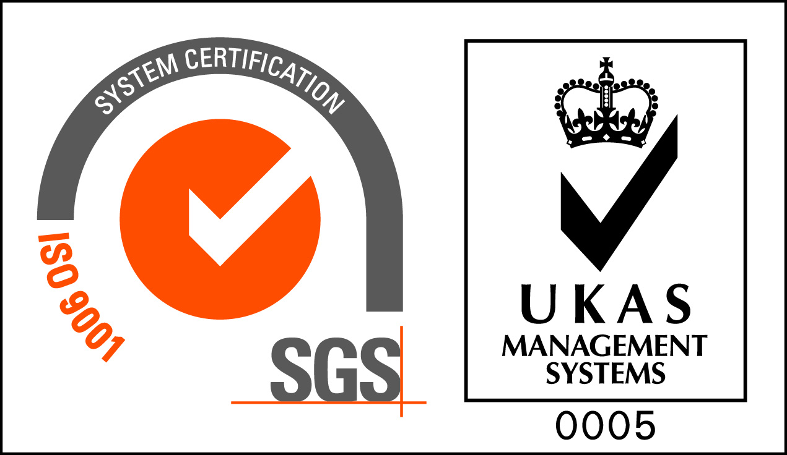 Kibabii University is ISO 9001:2008 Certified

